Sociology Preparation
This work is designed to help you move up from GCSE to A level studies by building on existing skills for a new subject. Sociology is a social science and as such relies on strong comprehension skills, clarity of writing, a wider social and political understanding, and the ability to see things from alternate points of view.

Task 1
Read the article ‘Being Sociological’.
Locate the following terms in the article and add a definition to the glossary below.
Term | Definition
Action Approach

Agency

Conventional Wisdom

Critical Thinking

Education System

Globalisation

Ideology

Institutions

Marginalisation

Material Conditions

Objectivity

Power Structures

Research Methods

Scientific Method

Social Action

Social Class

Social Control

Social Structure

Social World

Socialisation

Sociological Imagination

Sociology

Structural Approach

Validity

Answer these questions:
- What is sociology, according to the article?

- Why does the author argue that simple answers to social problems are often inadequate?

- How does the article suggest sociology can help people understand issues within education?

- Why does the article claim sociological knowledge is important in everyday life and employment?

- What concerns does the article raise about the reliability and validity of research evidence?

- Why does the author describe sociology as “a little contrary”?

Task 2
Sociologist | What did they believe? | What social problems were they interested in? | Were they more scientific or political? Why? | 1 reason why some people might question whether they were “real sociologists”
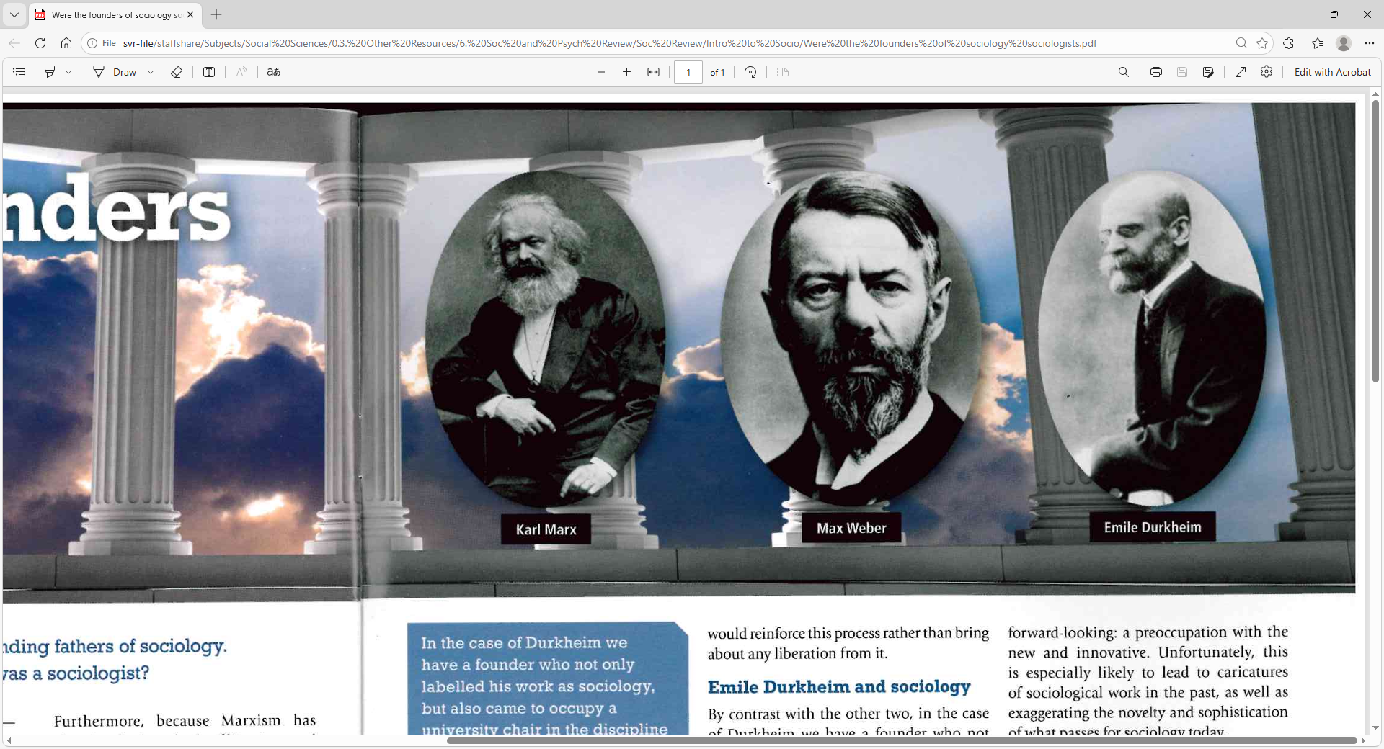
Read the article ‘Were the fathers of sociology sociologists?’ and complete the table:

Task 3
Read the following summary of the British Social Attitudes Survey No. 43 (2025).
Answer the questions at the end.

What is the British Social Attitudes Survey?
The British Social Attitudes (BSA) Survey has been carried out every year since 1983 by the National Centre for Social Research. It measures how people in Britain feel about important political and social issues.
The 2025 survey looked at:
- Taxation and government spending
- Welfare benefits
- Immigration
- Electoral reform
- Assisted dying
The survey interviewed 4,680 adults across the UK in autumn 2025.

1. Taxation and Government Spending
Key idea: “Thermostatic” public opinion
The report argues that public opinion behaves like a thermostat:
- When government spending is low, people want more spending.
- When spending becomes high, people start wanting lower taxes and less spending.
After COVID-19, government spending increased significantly. By 2025, many people were beginning to feel the state had become too large.
Main Findings
Attitudes towards tax and spending (2025)
Opinion | Percentage
Increase taxes and spending | 36%
Keep levels the same | 41%
Reduce taxes and spending | 19%
This was important because:
- Support for higher taxes and spending fell sharply after the pandemic.
- Support for cutting taxes and spending reached a record high.
Trend Over Time
Year | Increase Taxes & Spending | Reduce Taxes & Spending
1991 | 65% | 3%
2010 | 31% | 9%
2022 | 55% | 8%
2025 | 36% | 19%
What does this show?
The public mood has changed after the expansion of the state during COVID-19.
Sociologists and political scientists may link this to:
- Rising public debt
- Concerns about NHS performance
- Pressure on welfare spending
- Cost of living pressures
Political Polarisation
The report found strong differences between party supporters.
Support for increasing taxes and spending (2025)
Political Group | Support Increasing Spending
Labour / Lib Dem / Green supporters | 52%
Conservative / Reform supporters | 21%
This suggests Britain is becoming more politically divided on the role of the state.
A-Level Sociology Link
This section links to debates about:
- The welfare state
- Neoliberalism
- Government intervention
- Political polarisation

2. Welfare Attitudes
The Labour government tried to reduce welfare spending for working-age adults, especially around disability and mental health benefits.
Main Finding
Public support for welfare spending has fallen.
Agreement with the statement:
“The government should spend more money on welfare benefits for the poor, even if it leads to higher taxes.”
Year | Agree
1987 | 54%
2009 | 27%
2017 | 44%
2025 | 27%
By 2025, support had returned to its lowest ever level.
Why Has Support Fallen?
Possible reasons include:
- Concerns about the rising welfare bill
- Media focus on benefit spending
- Growing numbers claiming disability-related benefits
- Economic pressure after COVID-19
Which Benefits Do People Prioritise?
The survey asked which benefits should receive extra spending.
Highest priority for more spending (2025)
Benefit Type | Percentage
Retirement pensions | 34%
Benefits for disabled people | 30%
Child benefit | 20%
Single parents | 9%
Unemployment benefits | 3%
Important Trend
Support for spending on pensions has fallen a lot.
Year | Support More Spending on Pensions
2005 | 61%
2018 | 32%
2025 | 34%
At the same time:
- Support for disabled people increased.
- Support for child benefits reached record highs.
Sociological Significance
This suggests changing attitudes towards:
- Age inequality
- Welfare deservingness
- Disability
- Family support
A-Level Sociology Link
Useful for:
- Welfare state debates
- New Right views on welfare dependency
- Social policy
- Media influence on public opinion

3. Immigration
Immigration remains one of the most debated political issues in Britain.
The report examined whether people think immigration is:
- Good or bad for the economy
- Enriching or damaging to culture
Main Finding
Public attitudes became more negative after record levels of migration in recent years.
Economic Impact of Immigration
Views in 2025
Opinion | Percentage
Immigration is good for the economy | 32%
Neutral | 33%
Immigration is bad for the economy | 33%
Cultural Impact of Immigration
Opinion | Percentage
Immigration enriches culture | 32%
Neutral | 33%
Immigration undermines culture | 34%
Britain is now almost evenly divided on immigration.
Long-Term Trends
Economic impact attitudes
Year | “Good” | “Bad”
2011 | 21% | 42%
2022 | 50% | 17%
2025 | 32% | 33%
This shows:
- Attitudes became more positive after the Brexit referendum.
- They became more negative again after recent migration increases.
However, attitudes are still less negative than they were in 2011.
Political Polarisation
Immigration attitudes are now strongly linked to political identity.
Views on immigration’s economic impact (2025)
Political Group | Positive View | Negative View
Labour / Lib Dem / Green | 53% | 13%
Conservative / Reform | 13% | 57%
This is one of the clearest examples of political division in modern Britain.
A-Level Sociology Link
This section connects to:
- Globalisation
- National identity
- Right-wing populism
- Media representations of migrants
- Brexit

4. Electoral Reform
Britain currently uses the First Past the Post (FPTP) voting system.
The 2024 election produced a very disproportional result:
- Labour won 63% of seats with only 34% of the vote.
- Reform UK won 14% of votes but only 1% of MPs.
This increased debate about changing the voting system.
Main Finding
More people now support electoral reform.
Support for changing the voting system
Year | Support Change
1987 | 30%
2010 | 41%
2021 | 51%
2024 | 60%
2025 | 53%
Even though support fell slightly in 2025, a majority still favoured reform.
Party Differences
Support for changing the voting system (2025)
Party Supporters | Support Change
Greens | 76%
Reform | 61%
Liberal Democrats | 60%
Labour | 50%
Conservatives | 44%
Why Does This Matter?
The report suggests Britain’s traditional two-party system is weakening.
People increasingly feel:
- Smaller parties deserve fairer representation.
- FPTP can distort election results.
- Politics is becoming more fragmented.
A-Level Politics / Sociology Link
Useful for:
- Democracy and representation
- Political participation
- Legitimacy
- Constitutional reform

5. Assisted Dying
Assisted dying became a major political debate after proposed laws in:
- England and Wales
- Scotland
The survey explored whether people support doctors helping terminally ill people end their lives.
Main Finding
Public support for assisted dying remains very high and stable.
Terminal Illness Cases
Should assisted dying be allowed?
Year | Support
1995 | 80%
2016 | 78%
2025 | 79%
Public opinion has remained remarkably stable for 30 years.
Non-Terminal Illness Cases
Support is lower but has increased.
Year | Support
1995 | 41%
2016 | 51%
2025 | 62%
This suggests growing support for broader assisted dying laws.
Scotland
Attitudes in Scotland were almost identical to the rest of Britain.
Support in Scotland (2025)
Situation | Support
Terminal illness | 81%
Non-terminal illness | 62%
Sociological Importance
This issue raises debates about:
- Ethics
- Religion
- Individual rights
- Medical authority
- Social change
The report notes that religious people were more likely to oppose assisted dying.

Overall Conclusions
The 2025 British Social Attitudes survey shows that Britain is becoming:
- More politically divided
- More polarised on key issues
- Less supportive of state spending
- More divided over immigration
- More supportive of electoral reform
However, assisted dying is one issue where opinion has stayed stable and there is broad agreement.
Key Theme: Political Polarisation
The report repeatedly highlights growing differences between:
- Conservative/Reform supporters
- Labour/Lib Dem/Green supporters
This is especially visible in attitudes towards:
- Taxation
- Welfare
- Immigration
Final Evaluation
The report suggests Britain may be entering a new political era where:
- Traditional party loyalties are weakening
- Political divisions are deepening
- Public opinion is more fragmented
- Pressure for constitutional reform is increasing

Key Terms Glossary
Key Term | Meaning
Welfare state | Government support through benefits and public services
Political polarisation | Growing division between political groups
First Past the Post | Electoral system where the candidate with most votes wins
Proportional representation | Electoral system where seats more closely match vote share
Thermostatic theory | Idea that public opinion changes depending on current spending levels
Assisted dying | Helping someone legally end their own life under certain conditions
Net migration | Difference between people entering and leaving a country
Austerity | Government policy of reducing public spending

Source: British Social Attitudes 43: A First Look (National Centre for Social Research, 2026)

Questions:
- Explain how public attitudes towards welfare have changed in Britain.

- Analyse the reasons for political polarisation in modern Britain.

- Evaluate whether Britain should reform its electoral system.

- Examine changing attitudes towards immigration.

- Assess sociological explanations for support for assisted dying.

- Explain the pros and cons of using statistics in sociology.

Suggestions for Wider Learning
Watch: https://www.ted.com/talks/michael_kimmel_why_gender_equality_is_good_for_everyone_men_included
Listen: Pick one or more episodes from ‘Uncommon Sense’ from the Sociological Review https://thesociologicalreview.org/podcasts/uncommon-sense/
Read: ‘Journal Coner’ from the British Sociological Association https://www.discoversociology.co.uk/features/media/

